**Session 4**

**VESIT-Cloudera Academy**

**Date : 25th July 2020 time 10.00A.M to 12.00P.M**



**Speaker** **name** : Mr. Suraj Ghimire,

Apple India Pvt Ltd, Hyderabad   
Online Learning Center Pvt Ltd, Hyderabad.

**Topic**: Big Data-Spark Streaming with Kafka, Understanding how it all works in realtime.

**Box** **info**: What is Bigdata Hadoop Spark, What is Kafka,Core concept of Spark and Spark Streaming,  
How to work on Kafka and Spark Streaming.

Session 6

**VESIT_AIA Academy**

**Date 26th July 2020, time 10.00A.M to 12.00P.M**

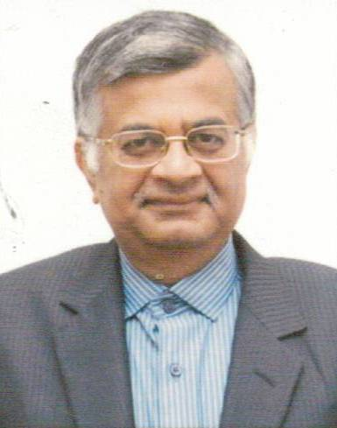

**Speaker name:** Chandrashekar Iyer

Retired as Executive Director Bharat Petroleum Mumbai Refinery

**Topic**: Industrial Revolution 4.0 (Manufacturing sector)

**Box content :** The talk would cover the emerging trends of using digitalization in the manufacturing sector for improved operational excellence, safety , health & environment as well as for better  project conceptualization & execution.